|  |  |  |  |
| --- | --- | --- | --- |
| **11th September 2022**  ***Psalter Week 4*** | Twenty-Fourth Sunday of the Year | | |
| **First Reading** | **Exodus 32:7-11. 13-14**  *The Lord relented and did not bring on his people the disaster he had threatened.* | | |
| **Responsorial Psalm** | **I will leave this place and go to my father.** | | |
| **Second Reading** | **St Paul to Timothy 1:12-17**  *Christ Jesus came into the world to save sinners* | | |
| **Gospel Acclamation** | **Alleluia, alleluia! May the Father of our Lord Jesus Christ enlighten the eyes of our mind, so that we can see what hope his call holds for us. Alleluia!** | | |
| **Gospel** | **Luke 15:1-32**  *There will be rejoicing in heaven over one repentant sinner.* | | |
| **Saturday 10th September +** | | **5.45pm**  **6.30pm** | **Confession**  **Vigil Mass –** *(For the Parish)* |
| **Sunday 11th September +** | | **10.30am** | **Mass –** *(Jane and Anthony Medlicott- Diamond Wedding Anniversary)* |
| **Monday 12th September**  **The Most Holy Name of Mary** – *mem* | | **10.00am** | **Mass –** *(Ben Bird RIP)* |
| **Tuesday 13th September**  **St John Chrysostom,** *Bishop & Doctor* | | **10.00am** | **Mass –** *(HM Queen Elizabeth II RIP)* |
| **Wednesday 14th September**  **THE EXALTATION OF THE HOLY CROSS** | |  | **No Parish Mass today** |
| **Thursday 15th September**  **Our Lady of Sorrows** - *memoria* | | **9.15am**  **10.00am** | **Exposition of the Blessed Sacrament**  **Mass –** *(Sydney Ayles RIP)* |
| **Friday – 16th September**  **Ss Cornelius,** *Pope &* **Cyprian,** *Martyrs* | | **6.15pm**  **7.00pm** | **Exposition of the Blessed Sacrament**  **Mass –** *(* *Siobhan Galvin Int.)* |
| **Saturday – 17th September**  **St Hildegard of Bingen,** *Virgin & Doctor* | | **10.00am**  **10.30am– 11.30am** | **Mass –** *(Bernadette Barrett-John Int.)*  **Exposition of the Blessed Sacrament**  **Confession** |
| **TWENTY-FIFTH SUNDAY OF THE YEAR** | | | |
| **Saturday – 17th September +** | | **5.45pm**  **6.30pm** | **Confession**  **Vigil Mass –** *(For the Parish)* |
| **Sunday – 18th September +** | | **10.30am** | **Mass *–*** *(Fr John Fowler RIP)* |

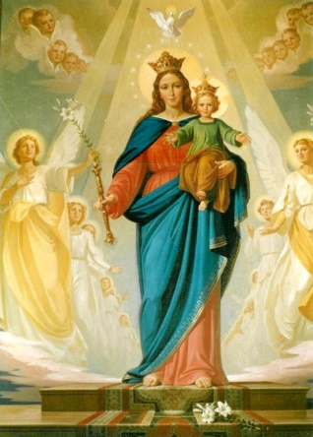

*Parish of Our Lady Help of Christians & St Lawrence*

39-41 West Street, Olney MK46 5HH

**Diocese of Northampton**

Parish Priest: Fr David B Barrett [olneyparishpriest@icloud.com](mailto:olneyparishpriest@icloud.com)

Fr Brian Leatherland *(Rtd)*

Deacon: Rev Peter Griffin – 07850 499414 [pfgriffin@hotmail.co.uk](mailto:pfgriffin@hotmail.co.uk)

Parish Website: [www.ourladysolney.co.uk](http://www.ourladysolney.co.uk)

Parish Secretary: Denise Wallinger

Telephone: 01234 711212 [ourladysolney@btconnect.com](mailto:ourladysolney@btconnect.com)

St Joseph’s Convent – Sr Delia DHS - 01234 711267

Turvey Abbey – 01234 881432

**SVP Contact: 07925 125206**

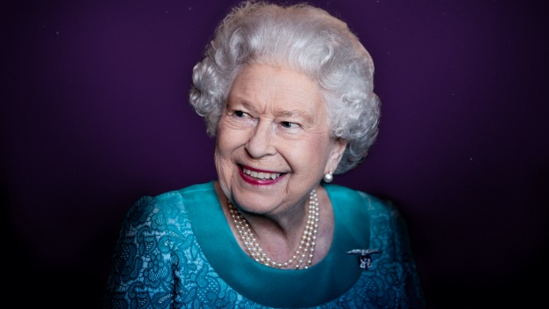

**Queen Elizabeth II**

**1926 – 2022**

**FOR THE HAPPY REPOSE OF QUEEN ELIZABETH II**

Almighty God,  
You are the author and sustainer of all human life;  
grant that your servant, Elizabeth our Queen,  
whom you granted a long and happy reign as Monarch of these lands,  
may be forgiven her sins and rewarded with that eternal life  
promised to all those born again  
in the water of baptism and power of your Spirit.

Through our Lord Jesus Christ, your Son, who lives and reigns with you in the unity of the Holy Spirit God, forever and ever. Amen.

Eternal rest grant unto her, O Lord,  
And let perpetual light shine upon her.

May she rest in peace. Amen.

May her soul, and the souls of all the faithful departed,  
Through the mercy of God, rest in peace. Amen

**PSALM 121 – A SONG OF ASCENTS**

I lift up my eyes to the mountains;  
from where shall come my help?  
My help shall come from the Lord  
who made heaven and earth.

May he never allow you to stumble!  
Let him sleep not your guard.  
No, he sleeps not nor slumbers,  
Israel’s guard.

The Lord is your guard and your shade;  
at your right side he stands.  
By day the sun shall not smite you,  
nor the moon in the night.

The Lord will guard you from evil;  
he will guard your soul.  
The Lord will guard your going and coming,  
both now and forever.

**CANTICLE OF SIMEON** (**Luke 2:29-32)**

At last, all-powerful Master,  
you give leave to your servant  
to go in peace, according to your promise.

For my eyes have seen your salvation  
Which you have prepared for all nations,  
The light to enlighten the Gentiles  
And give glory to Israel, your people.

**PRAYER FOR THE ROYAL FAMILY**

Almighty God, source of all consolation,  
we pray for the members of the Royal Family who mourn the loss  
of Her Majesty Queen Elizabeth.  
Uphold them in your love  
and pour out on them the consolation of your healing Spirit.  
Let them find in your Son, our Lord Jesus Christ,  
comfort in their sadness, certainty in their doubt  
and courage to live through this hour.  
We ask this through Christ our Lord. Amen.

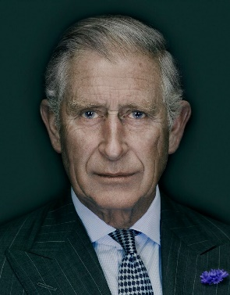

**PRAYER FOR KING CHARLES III**

O God, to whom every human power is subject,  
Grant to your servant His Majesty the King  
wisdom in the exercise of his high office,  
so that, always revering you and striving to please you,  
he may constantly secure and preserve  
for the people entrusted to his care  
the freedom that comes from unity and peace.

Through our Lord Jesus Christ, your Son,  
Who lives and reigns with you in the unity of the Holy Spirit,  
God, forever and ever. Amen.

**SECOND COLLECTION THIS WEEKEND FOR THE WORK OF THE SVP**

**SECOND COLLECTION NEXT WEEK FOR HOME MISSIONS**

**CAFOD – PAKISTAN FLOOD APPEAL –** Our Parish CAFOD Group sincerely thank you all for your very generous response to last Sunday’s appeal which raised the magnificent total of **£660.00**

**PARISH CHOIR** - There will be a meeting for choir members in the church on **Monday 12th** **September at 7.30pm***.* If you enjoy singing and can regularly attend the practice sessions on a Monday evening you will be most heartily welcome.

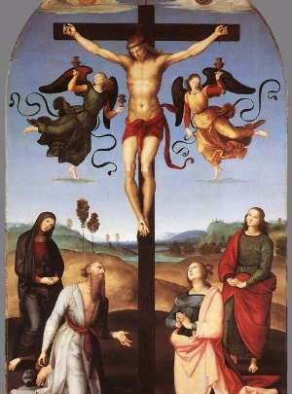

The Exaltation of the Holy Cross

The one symbol most often identified with Jesus and his Church is the Cross. On Tuesday we celebrate The Exaltation of the Holy Cross. This feast traces its beginning to Jerusalem and the dedication of the church built on the site of Mount Calvary in 335. But the meaning of the Cross is deeper than any city, any celebration, any building. The Cross is a sign of suffering, a sign of human cruelty at its worst. But by Christ’s love shown in the Paschal Mystery, it has become the sign of triumph and victory, the sign of God, who is love itself. Believers have always looked to the Cross in times of suffering. People in concentration camps, in prisons, in hospitals, in any place of suffering and loneliness, have been known to draw, trace, or form crosses and focus their eyes and hearts on them. The cross does not explain pain and misery; it does not give us any easy answers; but it does help us to see our lives united with Christ’s. We often make the Sign of the Cross over ourselves; we make it before prayer to help fix our minds and hearts on God; we make it after prayer, hoping to stay close to God. In trials and temptations, the Cross is a sign of strength and protection, it is the sign of the fullness of life that is ours. At Baptism, too, the Sign of the Cross is used; the priest/deacon, parents, and godparents make the sign on the forehead of the child – *‘claiming the child for Christ’.*  On this special feast let us look to the Cross often; let us make the Sign of the Cross and realise we bring our whole selves to God—our minds, souls, bodies, thoughts and hearts; everything we are and will become.

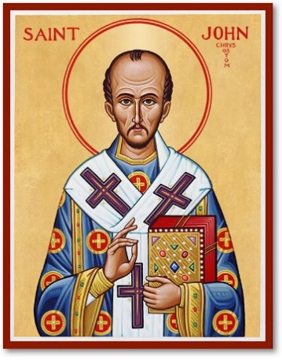St John Chrysostom Bishop & Doctor of the Church

Born at Antioch about the year 349. After a brilliant course of studies, he began to lead a life of austerity. He was ordained priest and laboured in preaching, with great fruit. In 397 he became Bishop of Constantinople and showed himself a true pastor, striving to reform the morals of both clergy and people. He incurred the hatred of the imperial court and his work was undermined because of jealousy, and twice he was sent into exile. Overcome by exhaustion he died at Comana in Pontus on 14th September 407. Because of his sermons and writings to explain the faith and to encourage the practice of the Christian life he was called ‘John of the Golden Mouth’

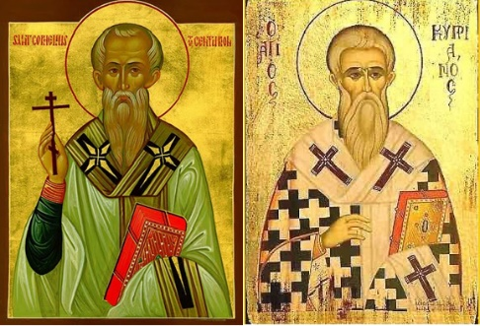Ss Cornelius & Cyprian

Cornelius was ordained Bishop of Rome in the year 251. He laboured to combat the Novatian schism and with the help of Cyprian he was able to enforce his authority. He was sent into exile by the Emperor Gallus, and he died at Civitavecchia (Rome) in the year 253. His body was brought to Rome and interred in the cemetery of Callistus. Cyprian was born at Carthage about the year 210. He was converted to the faith in mature life and ordained priest. He was ordained Bishop of Carthage in 249. He guided his church excellently during much troubled times both by his deeds and his writings. During the persecution of Valerian, he was first exiled, then, on 14th September 258, martyred for the faith.

May Our Lady, Help of Christians, St Lawrence, St Joseph, St John Henry Newman,

St Rita, St John Chrysostom, Ss Cornelius & Cyprian pray for us all.

With our love and prayers – Fr David & Deacon Peter